Logo_CAZMATRANS-Promet-VU_novi_logo_1

**LINIJA: 702**

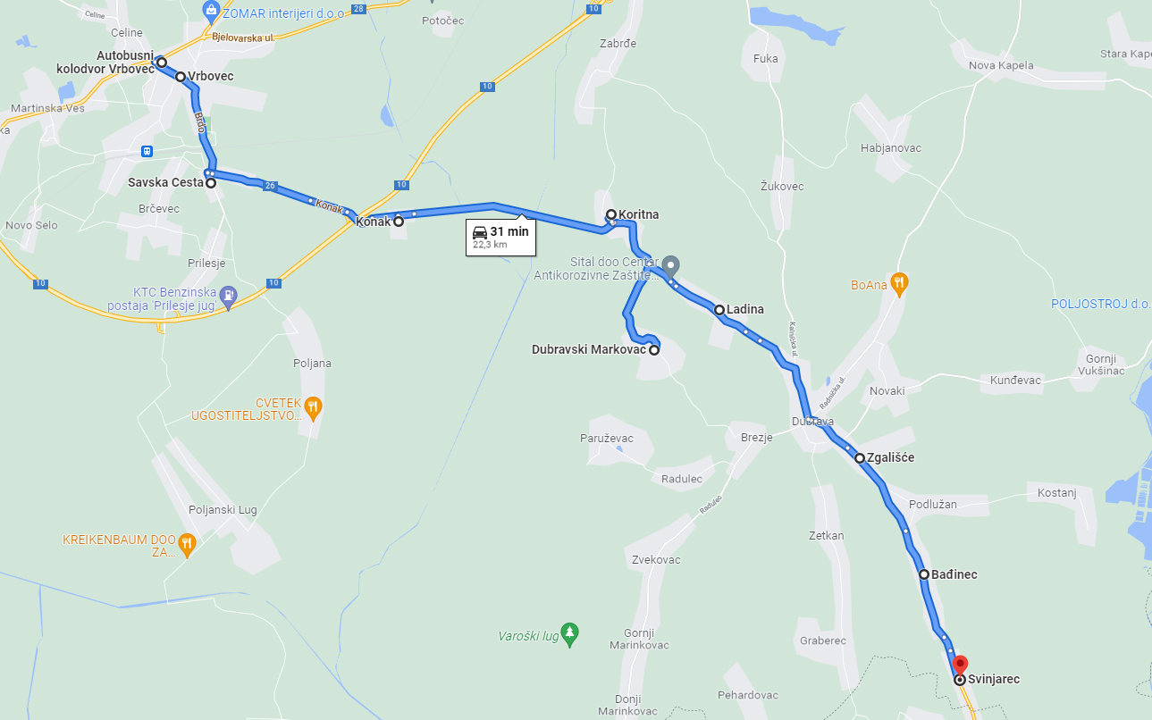**ĐURIŠTE – VRBOVEC – DUBRAVA - SVINJAREC**