Logo_CAZMATRANS-Promet-VU_novi_logo_1

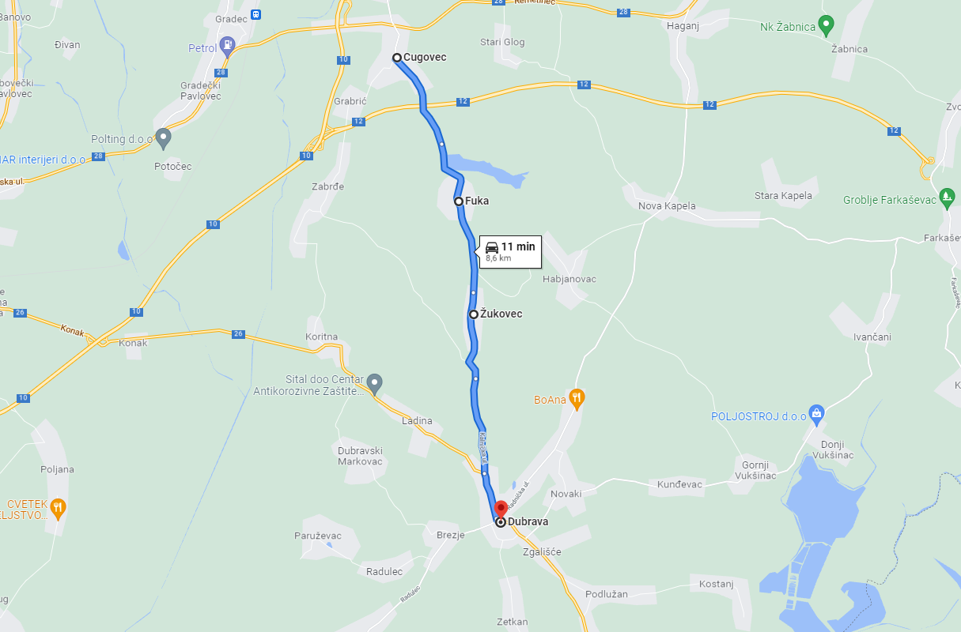**LINIJA: 710**

**CUGOVEC - DUBRAVA**