Logo_CAZMATRANS-Promet-VU_novi_logo_1

**LINIJA: 709**

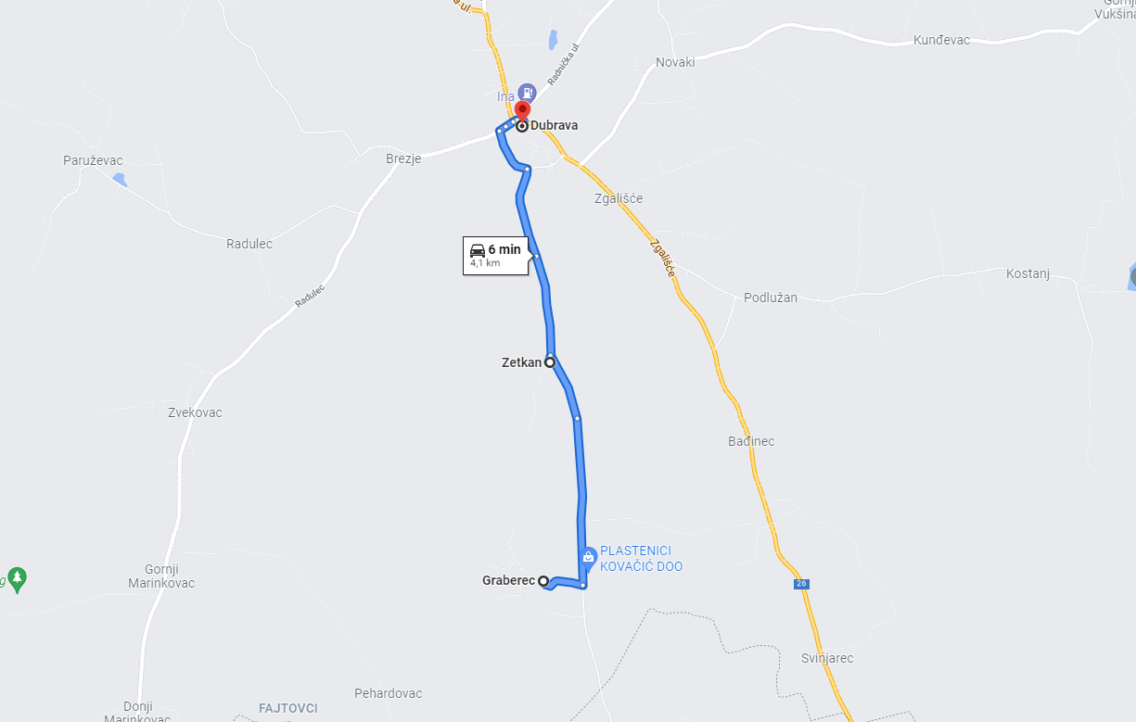**GRABEREC - DUBRAVA**